

**UGANDA NATIONAL EXAMINATIONS BOARD**

**PRIMARY SEVEN MOCK EXAMINATIONS (ANWAR)** **2024**

**INTEGRATED SCIENCE**

**Time allowed: 2 hours 15minutes**

**Index No.**

|  |  |  |  |  |  |  |  |  |
| --- | --- | --- | --- | --- | --- | --- | --- | --- |
| **Random No.** | | | | | | **Personal No.** | | |
|  |  |  |  |  |  |  |  |  |

**Candidates Name:** ………………………………………………………………………………..………………….

**Candidates’ Signature:** …………………………………………………………………………………………….

**School Random No:** …………………………………………………………………………………………..…….

**District ID:** …………………………………………………………………………….………………………………..

**Read the following instructions carefully:**

|  |  |  |
| --- | --- | --- |
| **FOR EXAMINERS’**  **USE ONLY** | | |
| **QN. NO.** | **MARKS** | **EXR’S NO** |
| 1 - 5 |  |  |
| 6 - 10 |  |  |
| 11 - 15 |  |  |
| 16 – 20 |  |  |
| 21 – 22 |  |  |
| 23 – 24 |  |  |
| 25 – 26 |  |  |
| 27 – 28 |  |  |
| 29 – 30 |  |  |
| 31 – 32 |  |  |
| **TOTAL** |  |  |

1. Do not write your **school** or **district name** anywhere on this paper.

2. This paper has two sections **A** and B. Section **A** has

**40 questions** and **section B** has **15 questions**. This paper has **12 pages** printed altogether.

3. Answer **all** questions. All the working for both sections

**A** and **B** must be shown in the spaces provided.

4. **All** working must be done using a **blue** or **black** ball point pen or ink. Any work done in pencil other than graphs and diagrams will  **NOT** be marked.

5. **No calculators** are allowed in the examination room.

6. Unnecessary **changes** in your work and handwriting that cannot be easily ready may lead to loss of marks.

7. Do not fill anything in the box indicated: **“For examiners’ use only**” and the boxes inside the

question paper.

©2024 Uganda National Examinations Board **Turn Over**

**SECTION A:**

1. Which body organ is used for tasting?

..............................................................................................................................................................................................................................................................

1. What does the term “vice” mean in poultry keeping?

..............................................................................................................................................................................................................................................................

1. How is a seed different from a fruit?

..............................................................................................................................................................................................................................................................

1. Why are metals painted?

..............................................................................................................................................................................................................................................................

1. Mention one characteristic which makes a spider not to be grouped under insects.

..............................................................................................................................................................................................................................................................

1. Why do people preserve food?

..............................................................................................................................................................................................................................................................

1. How are conifers different from other non-flowering plants?

..............................................................................................................................................................................................................................................................

1. What property of air does the diagram illustrate?

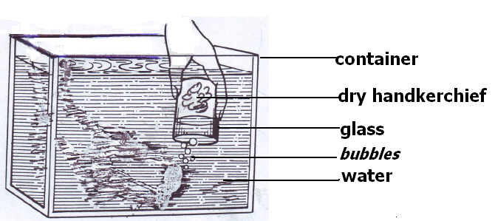..............................................................................................................................................................................................................................................................

1. Give the function of a pinna in a human ear

……………………………………………………………………………………………………………………………………………………………………

1. Explain how plants are used as energy resources in our environment

…………………………………………………………………………………........……………………………………………………………………………….

1. Name the type of change that takes place when mangoes ripen.

…………………………………………………………………………………………………………………………………………………………………...

12 Why does a needle placed gently on the surface of water float?

…………………………………………………………………………………………………………………………………………………………………...

1. What is the importance transpiration to plants?

…………………………………………………………………………………………………………………………………………………………………...

1. What component of loam soil makes it most suitable for growing crops?

…………………………………………………………………………………………………………………………………………………………………...

1. State the importance of grit in the digestive system of a bird.

…………………………………………………………………………………………………………………………………………………………………...

1. Identify one example of a magnetic substance.

…………………………………………………………………………………………………………………………………………………………………...

1. Smoking is very bad to human health. Why does the government of Uganda

License companies that make cigarettes? …………………………………………………………………………………………………………………………………………………………………...

1. Write CDD in full.

……………………………………………………….………………………………………………………………………………………..…………………..

1. Why are people encouraged to drink boiled water?

……………………………………………………………………………………………………………………………………….………………………………...

1. A female fish lays eggs in water. How are these eggs fertilized?

……………………………………………………………………………………………………………………………………..…..……………………………...

1. Nanku burnt herself with a hot flat iron. What type of injury did she get?

………………………………………………………………………………………………………………………………………………………………………...

**Use the diagram below to answer question 22.**

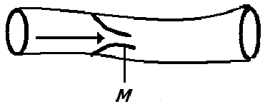

1. What is the importance of the structure marked M in the above blood vessel?

………………………………………………………………………………………………………………………………………………………………………...

1. Give one difference between a sprain and a strain.

………………………………………………………………………………………………………………………………………………………………………...

1. In which part of a human body are red blood cells made?

………………………………………………………………………………………………………………………………………………………………………...

1. Identify the body part an insect uses for balancing during flight.

………………………………………………………………………………………………………………………………………………………………………...

1. What does the term “resource” mean?

…………………………………………………………………………………………………………………………………………………………………...

1. Why do we see the flash of lightning before we hear the sound of thunder during rain storms?

………………………………………………………………………………………………………………………………….……………………………………...

1. Write down the vector that spreads elephantiasis.

………………………………………………………………………………………………………………………………………………………………………...

1. Convert 1000C to 0F.
2. 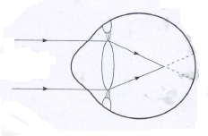What eye defect is shown in the diagram below?

………………………………………………………………………………..

1. Why is the measles vaccine administered at the age of nine months?

…………………………………………………………………………………………………………………………………………………………………...

1. State one advantage of family planning.

…………………………………………………………………………………………………………………………………………………………………...

1. Identify one psychological characteristic which is common in adolescents

…………………………………………………………………………………………………………………………………………………………………...

1. Apart from getting sunlight, why else do weak stems climb others

…………………………………………………………………………………………………………………………………………………………………...

1. How does rural electrification help in conserving the environment?

………………………………………………………………………………………………………………………………………..…..…………………………...

1. Name one cold blooded vertebrate that has a bony shell.

………………………………………………………………………………………………………………………………………………………………………...

1. Identify one health reason why building industries should be limited.

…………………………………………………………………………………………………………………………………………..……..……………………...

1. Why should wood being burnt into charcoal be covered with soil?

……………………………………………………………………………………………………………………………………...…………..……………………...

1. In the space provided below, draw a compound pinnate leaf.

……………………………………………………………………………………………………………………………………………….………………………...

1. Why is food digestion said to begin in the mouth?

………………………………………………………………………………………………………………………………………………………………………...

**SECTION B**

1. (a) What is a solute?

………………………………………………………………………………………………………………………………………………..……………….……...

(b) Give one solute used in making ORS. …………………………………………………………..…………………………………………………………………………………..……………………...

(c) Why is water said to be a universal solvent? ………………………………………………………….……………………………………………………………………………….………………………...

(d) What health condition can be treated using ORS? ……………………………………………………….………………………………………………………………………………….………………………...

1. 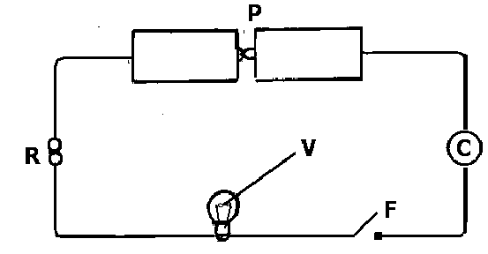**The diagram below shows an electric circuit. Study it carefully and answer the questions about it.**

(a) Name part marked F. …………………………………………………………………………………………………………………………………………………………………...

(b) Give the function of part marked R. …………………………………………………………………………………………………………………………………………………………………...

(c) What form of energy is contained in part marked P? …………………………………………………………………………………………………………………………………………………………………...

(d) Why should part marked V fail to produce light when F is closed? …………………………………………………………………………………………………………………………………………………………………...

1. **Study the diagram and answer the questions about it.**

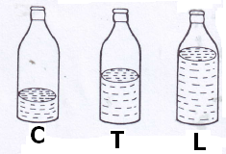

1. Which of the bottles, when air is blown into them, will produce sound of the highest pitch?

…………………………………………………………………………………………………………………………………………………………………… (b) Give a reason for your answer in (a) above. ………………………………………………………………………………………………………………………………………………………………………...

(c) How can you make the bottles to produce the same sound pitch of sound? ………………………………………………………………………………………………………………………………………………………………………...

(d) What does the term “volume of sound” mean? ………………………………………………………………………………………………………………………………………………………………………...

44(a) Give one example of a legume. …………………………………………………………………………………………………………………………………..……………………………………………………

b) How are nitrates important to leguminous plants?

……………………………………………………………………………………………………………………………………………………………

c) What food value do we get from leguminous plants?

……………………………………………………………………………………………………………………………………………………………

(d) Apart from root nodules, given any other characteristic of leguminous plants.

……………………………………………………………………………………………………………………………………………………………

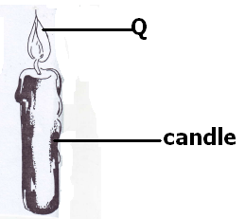45. **The diagram shows a burning candle. Use it to answer the questions about it**.

(a) Name two forms of energy given off at Q. …………………………………………………………………………………………………………………………………………………………………………………………

(b) Which component of air supports the candle to burn? …………………………………………………………………………………………………………………………………………………………………………………………

(c) Identify one other process in living things that uses the same gas as in the experiment above. …………………………………………………………………………………………………………………………………………………………………………………………

46(a) Identify one type of cattle kept in Uganda. ………………………………………………………………………………………………………………………………………………………………………………………

1. Give the importance of the type of cattle you have named in (a) above.

…………………………………………………………………………………………………………………………………………………………………..………………

(c) Identify two advantages of rearing exotic breeds of cattle over local breeds of cattle. ……………………………………………………………………………………………………………………………………………………………

47(a) Define the following terms:

1. Temperature

………………………………………………………………………………………………………………………………………….…………….…………………………

(ii) boiling point

…………………………………………………………………………………………………………………………………………………….……………………………………

(iii ) heat

………………………………………………………………………………………………………………………………………………………..………………………………

(iv) evaporation

…………………………………………………………………………………………………………………………………………………………………………………..……

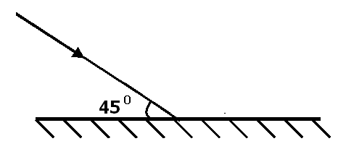48. **The diagram below shows a light ray being reflected through a plane mirror.**

(a) Complete the diagram above. ……………………………………………………………………………………………………………………………………………………………

(b) Calculate the value of the angle of reflection. ……………………………………………………………………………………………………………………………………………………………

(c) What type of reflection is shown in the diagram? ……………………………………………………………………………………………………………………………………………………………

(d) Give one characteristic of images formed through a plane mirror. ……………………………………………………………………………………………………………………………………………………………

49(a) What is Primary Health Care? ……………………………………………………………………………………………………………………………………………………………

(b) Give two elements of Primary Health Care. ……………………………………………………………………………………………………………………………………………………………

(c) State one activity done by a community in order to promote primary Health Care. ……………………………………………………………………………………………………………………………………………………………

50(a) Write AIDS in full. ………………………………………………………………………………………………………………………………………………..………………………………………

(b) Write down two ways through which AIDS is spread. ……………………………………………………………………………………………………………………………………………………………

1. What is the best way for a P. 7 pupil to avoid contracting AIDs?

……………………………………………………………………………………………………………………………………………………………

51. **Study the diagram below and answer the questions about**

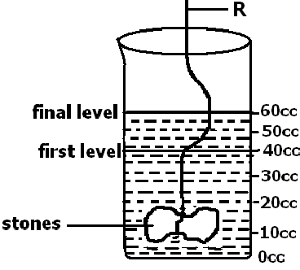

(a) Find the volume of the stone.

……………………………………………………………………………………………………………………………………………………………

(b) Give the use of the use of R in the experiment. ……………………………………………………………………………………………………………………………………………………………

(c) Why do objects weigh less in water than in air? ……………………………………………………………………………………………………………………………………………………………

(d) Name the method used to find the volume of the stone. ……………………………………………………………………………………………………………………………………………………………

52. **Study the diagram of the kidney and answer the questions that follow.**

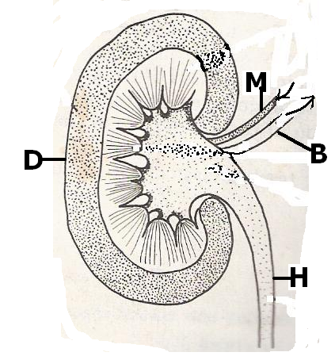

(a) Name the parts marked H and D. ……………………………………………………………………………………………………………………………………………………………

(b) Which type of blood is carried by blood vessel marked B? ……………………………………………………………………………………………………………………………………………………………

(c) Give one disease that affects the organ in the diagram above. ……………………………………………………………………………………………………………………………………………………………

b) Differentiate between primary consumers and secondary consumers. ……………………………………………………………………………………………………………………………………………………………

(c) Give two ways how plants depend on each other. ……………………………………………………………………………………………………………………………………………………………

54. **The diagram below shows a clinical thermometer**.

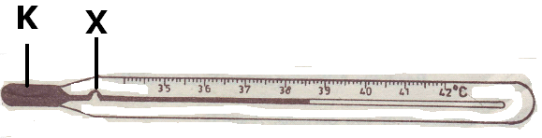

(a) What is the use of the above instrument? ……………………………………………………………………………………………………………………………………………………………

(b) Name liquid marked K. ……………………………………………………………………………………………………………………………………………………………

(c) In a human heart, which part carries out a similar function as part marked X? ……………………………………………………………………………………………………………………………………………………………

(d) Give the importance of part marked X. ……………………………………………………………………………………………………………………………………………………………

55. **Study the diagram below and answer the questions that follow.**

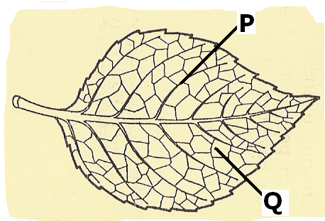

(a) Name part marked P……………………………………………………………………………………………………………………………………………………………

(b) What important process takes place in part marked Q? ……………………………………………………………………………………………………………………………………………………………

(c) Give two raw materials needed for the process named in (b) above to take place.

……………………………………………………………………………………………………………………………………………………………

**END**